Лабораторная работа №3
import sqlite3

class AuthManager:
def __init__(self, connection):
self.connection = connection
self.create_tables()

def create_tables(self):
with self.connection:
self.connection.execute("""
CREATE TABLE IF NOT EXISTS users (
id INTEGER PRIMARY KEY AUTOINCREMENT,
username TEXT NOT NULL UNIQUE,
password TEXT NOT NULL,
country TEXT NOT NULL,
balance REAL NOT NULL
)
""")

def register_user(self, username, password, country, balance):
with self.connection:
self.connection.execute("""
INSERT INTO users (username, password, country, balance)
VALUES ('{}', '{}', '{}', {})
""".format(username, password, country, balance))

def authenticate_user(self, username, password):
cursor = self.connection.cursor()
cursor.execute("""
SELECT * FROM users
WHERE username = '{}' AND password = '{}'
""".format(username, password))
return cursor.fetchone()

def delete_user(self, user_id):
with self.connection:
self.connection.execute("""
DELETE FROM users WHERE id = {}
""".format(user_id))

def get_user_by_id(self, user_id):
cursor = self.connection.cursor()
cursor.execute("""
SELECT * FROM users WHERE id = {}
""".format(user_id))
return cursor.fetchone()

def count_users_by_country(self, country):
cursor = self.connection.cursor()
cursor.execute("""
SELECT COUNT(*) FROM users WHERE country = '{}'
""".format(country))
return cursor.fetchone()[0]

def transfer_balance(self, from_user_id, to_user_id, amount):
with self.connection:
cursor = self.connection.cursor()
cursor.execute("SELECT balance FROM users WHERE id = {}".format(from_user_id))
from_balance = cursor.fetchone()[0]
if from_balance < amount:
raise ValueError("Insufficient funds")

self.connection.execute("""
UPDATE users SET balance = balance - {} WHERE id = {}
""".format(amount, from_user_id))

self.connection.execute("""
UPDATE users SET balance = balance + {} WHERE id = {}
""".format(amount, to_user_id))

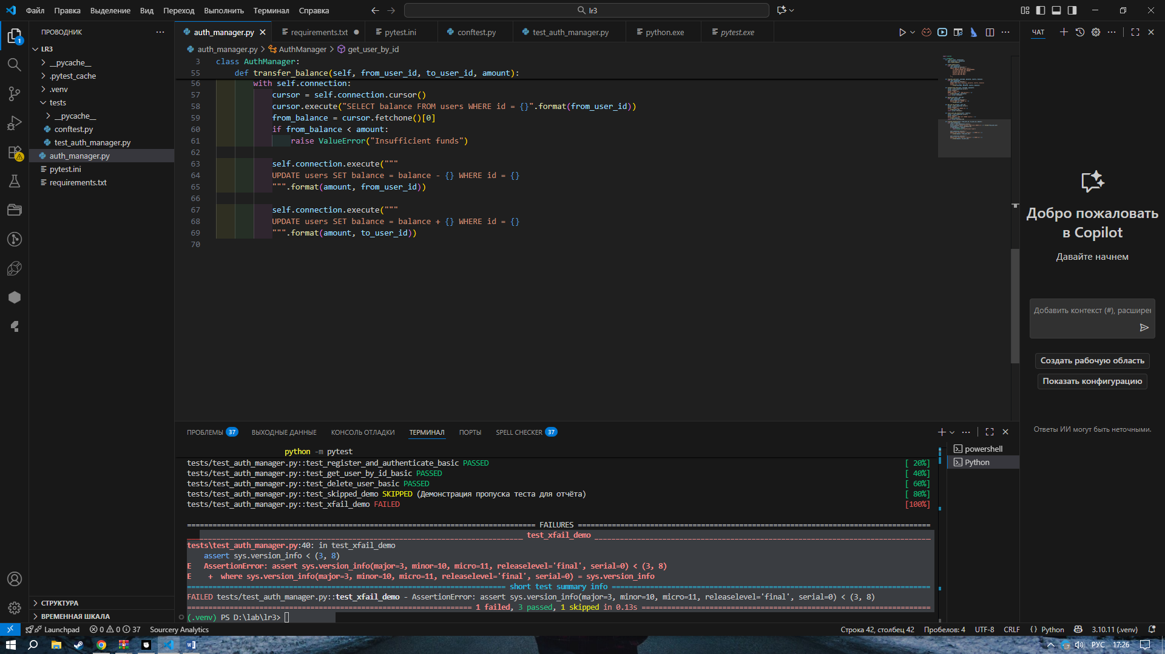

import pytest
import sys

# ---------- ПАРАМЕТРИЗОВАННЫЕ ТЕСТЫ (3) ----------
@pytest.mark.param
@pytest.mark.db
@pytest.mark.parametrize("country, expected_count", [
("CountryA", 2),
("CountryB", 1),
("CountryC", 0),
])
def test_count_users_by_country(three_users, country, expected_count):
count = three_users.count_users_by_country(country)
assert count == expected_count

@pytest.mark.param
@pytest.mark.db
@pytest.mark.parametrize("username,password,ok", [
("u1", "p1", True),
("u1", "bad", False),
("nosuch", "whatever", False),
])
def test_authenticate_param(auth_manager, username, password, ok):
auth_manager.register_user("u1", "p1", "X", 0)
row = auth_manager.authenticate_user(username, password)
assert (row is not None) == ok

@pytest.mark.param
@pytest.mark.db
@pytest.mark.parametrize("amount, expected_from, expected_to", [
(100, 900, 1100),
(250, 750, 1250),
(0, 1000, 1000),
])
def test_transfer_param(auth_manager, amount, expected_from, expected_to):
# from -> to
auth_manager.register_user("fromU", "s", "X", 1000)
auth_manager.register_user("toU", "s", "X", 1000)
from_id = auth_manager.authenticate_user("fromU", "s")[0]
to_id = auth_manager.authenticate_user("toU", "s")[0]
auth_manager.transfer_balance(from_id, to_id, amount)

got_from = auth_manager.get_user_by_id(from_id)[4]
got_to = auth_manager.get_user_by_id(to_id)[4]
assert got_from == expected_from
assert got_to == expected_to

# ---------- МЕТКИ/СКИП ----------
@pytest.mark.skip(reason="Демонстрация пропуска теста для отчёта")
def test_skipped_demo():
assert True

@pytest.mark.security
@pytest.mark.xfail(sys.version_info < (3, 8), reason="Требуется Python 3.8+ для демонстрации xfail", strict=False)
def test_xfail_demo():
assert sys.version_info < (3, 8)

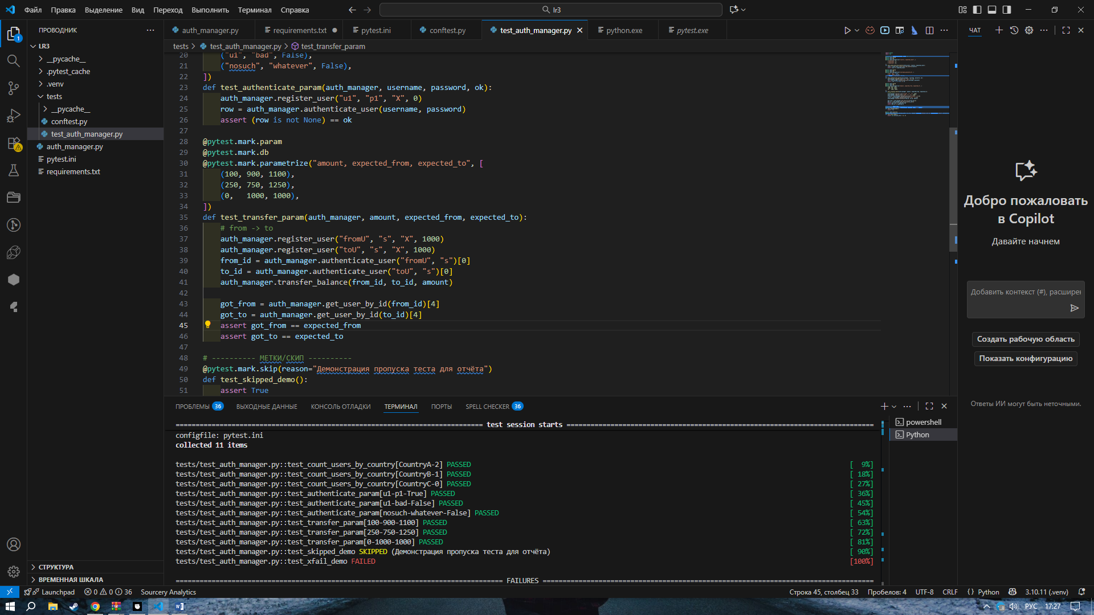

import pytest
import sys

# ---------- ТЕСТЫ ИСКЛЮЧЕНИЙ (2) ----------
@pytest.mark.exception
@pytest.mark.db
def test_transfer_insufficient_funds_raises(auth_manager):
auth_manager.register_user("A", "p", "X", 10)
auth_manager.register_user("B", "p", "X", 0)
a_id = auth_manager.authenticate_user("A", "p")[0]
b_id = auth_manager.authenticate_user("B", "p")[0]
with pytest.raises(ValueError, match="Insufficient funds"):
auth_manager.transfer_balance(a_id, b_id, 11)

@pytest.mark.exception
@pytest.mark.db
def test_register_duplicate_username_raises(auth_manager):
auth_manager.register_user("dup", "x", "X", 0)
with pytest.raises(Exception):
auth_manager.register_user("dup", "y", "X", 0)
# ---------- МЕТКИ/СКИП ----------
@pytest.mark.skip(reason="Демонстрация пропуска теста для отчёта")
def test_skipped_demo():
assert True

@pytest.mark.security
@pytest.mark.xfail(sys.version_info < (3, 8), reason="Требуется Python 3.8+ для демонстрации xfail", strict=False)
def test_xfail_demo():
assert sys.version_info < (3, 8)

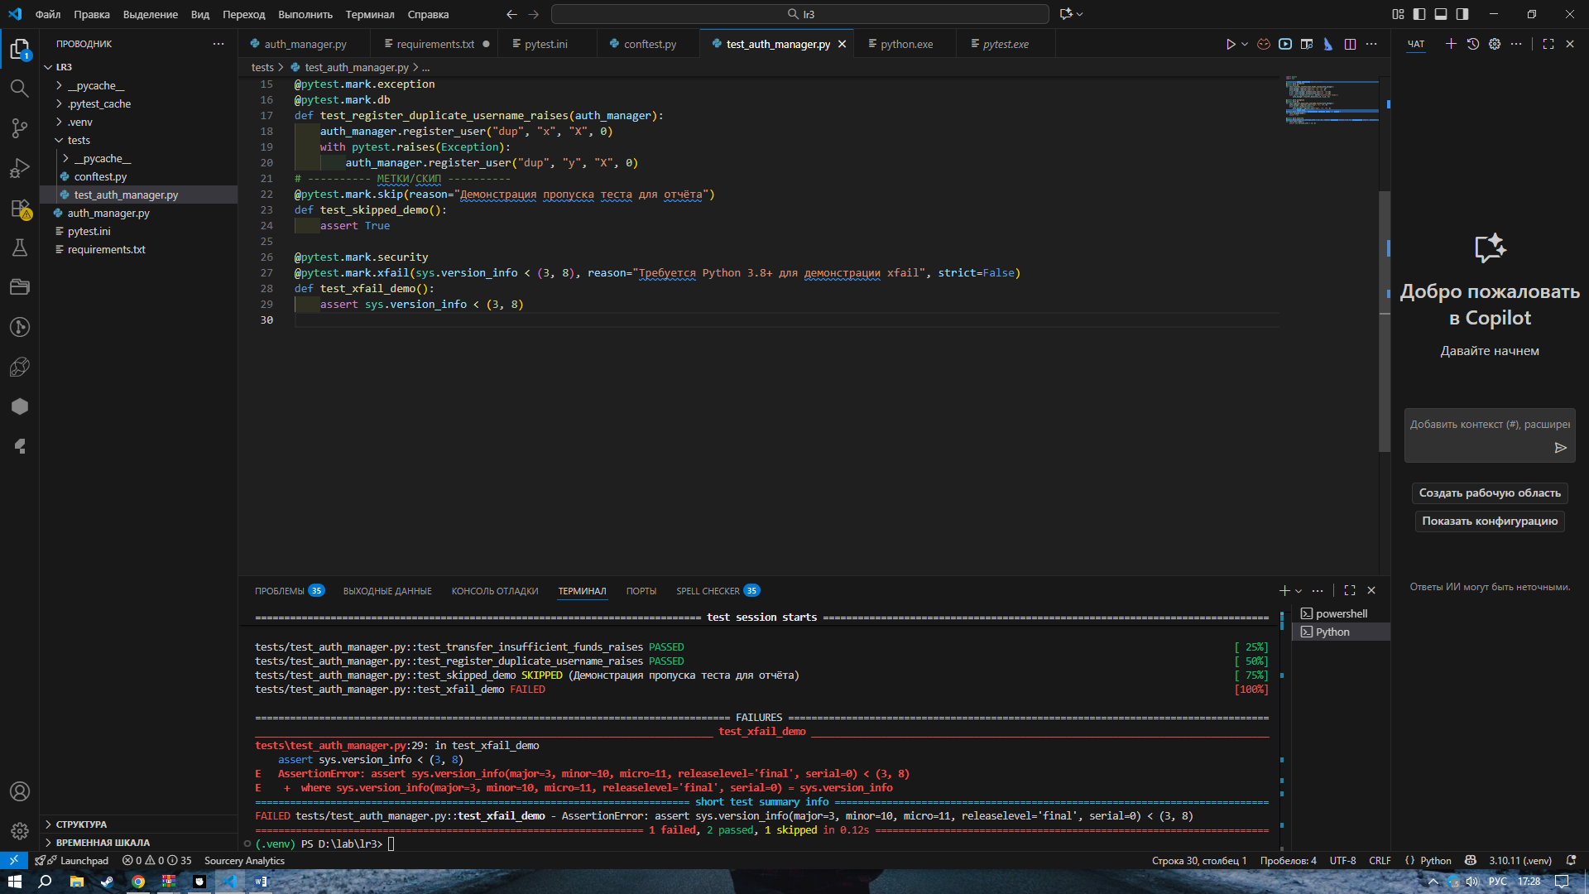

import pytest
import sys

# ---------- SQL-ИНЪЕКЦИЯ (обязательный) ----------
@pytest.mark.security
@pytest.mark.db
def test_sql_injection_authentication_bypass(auth_manager):
"""
Демонстрация уязвимости: из-за форматирования строк возможно
обойти пароль через инъекцию.
"""
auth_manager.register_user("admin", "goodpass", "RU", 0)

# Нормальный неправильный пароль → не должен логинить…
assert auth_manager.authenticate_user("admin", "wrong") is None

# …но из-за инъекции логин ПРОЙДЁТ (уязвимость!)
injected = "' OR '1'='1"
row = auth_manager.authenticate_user("admin", injected)
assert row is not None

# ---------- МЕТКИ/СКИП ----------
@pytest.mark.skip(reason="Демонстрация пропуска теста для отчёта")
def test_skipped_demo():
assert True

@pytest.mark.security
@pytest.mark.xfail(sys.version_info < (3, 8), reason="Требуется Python 3.8+ для демонстрации xfail", strict=False)
def test_xfail_demo():
assert sys.version_info < (3, 8)

